# 詹丽杏—EMT

By-神经所刘博奕

基本考点：

EMT定义，上皮细胞特征，间充质细胞特征；EMT的inducer,marker,pathways；

EMT与三种生理过程的关系（重点关注与肿瘤）

知识点：数字为在2020版PPT上的页数

1. EMT的定义（3）：The epithelial–mesenchymal transition(EMT) is a process by which epithelial cells lose their cell polarity and cell-cell adhesion, and gain migratory and invasive properties to become mesenchymal stem cells; these are multipotent stromal cells that can differentiate into a variety of cell types.
2. 上皮细胞（7）：Epitheliumis one of the four basic types of animal tissues, line the cavities and surfaces of blood vessels and organs throughout the body；

功能： secretion, selective absorption, protection, transcellular transport, and sensing.

特点： Unilayered or Muti-layered arrangement单层或分层

•Stable Cell-Cell/ECM Junction稳定的黏附

了解：黏附分子：E-cadherin-Catenin complex；Tight junction—Claudin and Occludin；Integrins

•Apical–Basolateral Polarization有极性

了解相关通路：LKB1；Scribble Complex；Crumbs complex；等

•Migration but limited in epithelial layer较差的迁移能力

1. 间充质细胞：（54）Mesenchymeis a type of tissue characterized by loosely associated cells that lack polarity and are surrounded by a large extracellular matrix。（松散连接，无极性）

例：Lymphatic, Circulatory systems, Connective tissues throughout the body,

such as bone and cartilage（胚胎起源的内胚层，内脏与表皮之间的血管，骨，淋巴等组织）（有转分化的能力）

特征：•Irregular arrangement无分层

•Loss of Cell-Cell/ECM Junction连接弱

•Loss of Apical–Basolateral Polarization无极性

•Motile and Invasive侵袭性

1. EMT步骤（67）：A：诱发因素

B：细胞骨架重构，向心性收缩

C-E：纵向延伸，脱离基底膜，伸出突起，破坏基底膜，表达间质细胞的粘附分子，至脱落。

1. EMT的marker：

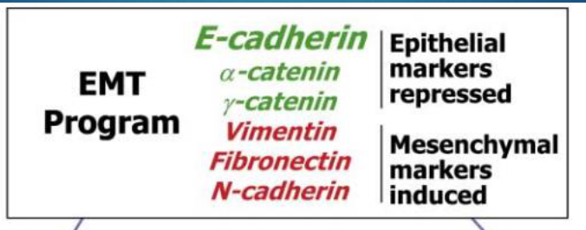绿色为上皮标志物，红色为间充质标志物

1. EMT的inducer：

Transcription factors：Snail，Twist，ZEB

TGFβ- induced EMT：smad and non-smad

Signalling pathways involved in EMT:：PI3K-AKT, Wnt, ERK-MAPK,

Growth factors：Wnt/ Wingless，Hedgehog (Hh)，TGF-/ BMP，FGF，Morphogen，HGF &HGFR，IGF-1，EGF，PDGF（110-132页，可能举几例）

microRNA：miR-200

Hypoxia

1. EMT过程中的变化：1.失去极性；2.细胞骨架的改变
2. EMT与生理过程的关系：
3. 发育：脊索动物的神经胚形成；三个胚层的形成（联系上文说的生长因子环路说明）
4. 纤维化：肾纤维化Renal Fibrosis；组织中的EMT（169）
5. EMT and Tumor progression

EMT is a central driver of epithelial-derived tumor malignancies

EMT has since been shown to trigger the dissociation of carcinoma cells from

primary carcinomas, which subsequently migrate and disseminate to distant sites.

关系：

1. EMT and Tumor progression
2. EMT and Tumor micro-environment
3. EMT induced metastasis and polarity pathway
4. EMT and Cancer stem cell
5. alternative splicing changes occurring during EMT
6. EMT and Drug resistance
7. EMT and anoikis resistance
8. EMT and immunosuppression

个人分析：

1. 出题可能会提一种细胞内的新发现分子，探究对肿瘤的影响，或者是设计（发现）一种新药物有抑制肿瘤的作用，从EMT的角度探究其作用机制

作答角度是确认该分子或药物对EMT是促进还是抑制（通过检测标记物），推测其作用的机制（举几个例子，比如作用于TGFβ），设计实验去验证它；

1. 也有可能是直接考察EMT的概念以及与生理过程的关系，照着答就行

分为正常生理状态（发育过程，以及转分化）及病理状态（多讲和肿瘤的关系）

1. 还有我觉得很细的通路基本没可能考，了解一下方便举例子，没时间建议不看。